

| **TITLE : To perform NLP on clinical data** |
| --- |

**AIM:** Named Entity Recognition on Healthcare Data

**Expected OUTCOME of Experiment:**

CO5: Apply data analytics in the field of Health care.

**_____________________________________________________________________**

**Books/ Journals/ Websites referred:**

**_____________________________________________________________________**

**Pre Lab/ Prior Concepts:**

Students should have a basic understanding of natural language processing concepts like named entity recognition.

**Procedure:**

**Data set Used: Pretrained spaCy model**

**Step1: Installed required library**

!pip install spacy

!python -m spacy download en_core_web_sm

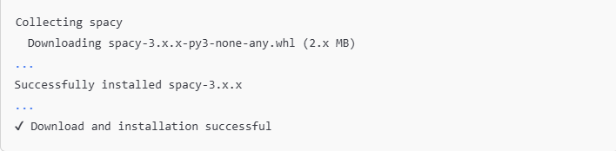

**Step2: Load pretrained spaCy model**

import spacy

# Load the pretrained model

nlp = spacy.load("en_core_web_sm")

nlp = spacy.load("en_core_web_sm")

**Step 3: Add Sample healthcare-related text**

# Sample healthcare text with more entities

text = (

    "Dr. Alice Johnson diagnosed John Doe with diabetes and prescribed metformin. "

    "He also underwent an MRI scan at City Hospital on 2023-10-15. "

    "The patient was previously treated for hypertension and is currently taking lisinopril. "

    "Additionally, he has a family history of heart disease and reports frequent headaches. "

    "The consultation was held in New York City, and Dr. Johnson emphasized the importance of diet and exercise."

)

**Step4: Process Text**

# Process the text with the NLP model

doc = nlp(text)

**Step 5: Print named entities**

# Print named entities in the text

for ent in doc.ents:

    print(ent.text, ent.label_)

Implementation details:

• **Environment Setup**:

* Ensure you have Python installed, preferably version 3.6 or higher.
* Install the spaCy library along with the English language model using pip. This will enable you to utilize the NLP functionalities provided by spaCy.

• **Library Import**:

* Import the spacy library, which will be used to access the natural language processing tools.

• **Loading the Pretrained Model**:

* Load the English language model using a specific function. This model includes pre-trained word vectors and supports named entity recognition (NER).

• **Defining Sample Healthcare Text**:

* Create a string variable that contains a sample healthcare-related narrative. This narrative should include various entities such as names of patients, medical conditions, medications, healthcare organizations, and dates.

• **Processing the Text**:

* Pass the defined healthcare text to the loaded NLP model. This step will analyze the text, tokenize it, and identify any named entities present in the content.

• **Extracting and Printing Named Entities**:

* Iterate through the identified entities obtained from the processed text. For each entity, display its text along with its corresponding label, which indicates the type of entity (e.g., PERSON, DISEASE, PRODUCT, ORGANIZATION, DATE, or GPE).

Output:

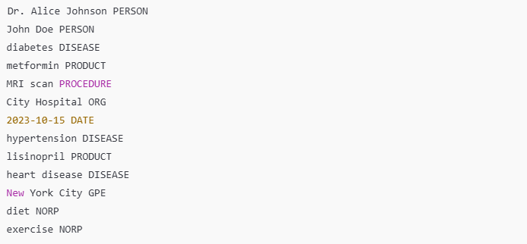

**Date: _____________ Signature of faculty in-charge**

**Post Lab Descriptive Questions:**

Q.1 What is Natural Language Processing (NLP) and how is it applied to healthcare data?

**Natural Language Processing (NLP)** is a subfield of artificial intelligence that focuses on the interaction between computers and humans through natural language. It involves the use of algorithms and models to understand, interpret, and generate human language in a way that is both meaningful and useful.

In healthcare, NLP is applied to various types of data, including clinical notes, patient records, research articles, and more. Some specific applications include:

* **Extracting insights** from unstructured data, such as identifying symptoms or medications in clinical notes.
* **Clinical decision support**, where NLP can assist healthcare providers by analyzing patient data and suggesting potential diagnoses or treatments.
* **Data mining** for research purposes, helping to extract relevant information from large volumes of medical literature.

Q.2 What are named entities in the context of healthcare NLP, and how can Named Entity Recognition (NER) be useful in medical texts?

**Named entities** are specific terms or phrases that refer to distinct objects or concepts, such as diseases, medications, medical conditions, or patient names. In the context of healthcare NLP, these entities can include:

* **Diseases** (e.g., diabetes, hypertension)
* **Medications** (e.g., aspirin, metformin)
* **Procedures** (e.g., MRI, surgery)
* **Anatomical terms** (e.g., heart, liver)

**Named Entity Recognition (NER)** is a process in NLP that identifies and classifies these entities in text. NER is useful in medical texts for several reasons:

* **Information extraction**: It helps in quickly locating key information from lengthy medical documents.
* **Data normalization**: By recognizing standardized terms, it facilitates data comparison and aggregation.
* **Clinical documentation improvement**: It can enhance the accuracy of electronic health records by ensuring that relevant entities are captured correctly.

Q.3 What are some common applications of NLP in healthcare, such as clinical decision support, medical coding, or patient sentiment analysis?

NLP has several practical applications in healthcare, including:

1. **Clinical Decision Support**: NLP can analyze patient records and provide real-time insights, helping clinicians make informed decisions regarding diagnosis and treatment options.
2. **Medical Coding**: NLP can assist in automating the coding of diagnoses and procedures by extracting relevant information from clinical notes, which improves billing accuracy and reduces administrative burdens.
3. **Patient Sentiment Analysis**: NLP can analyze patient feedback from surveys, social media, or reviews to gauge satisfaction and identify areas for improvement in patient care.
4. **Clinical Trial Recruitment**: NLP can help identify eligible patients for clinical trials by analyzing medical records and matching criteria.
5. **Predictive Analytics**: By analyzing patterns in patient data, NLP can help predict outcomes, such as the likelihood of readmission or the progression of diseases.

These applications demonstrate how NLP enhances efficiency, accuracy, and the overall quality of healthcare delivery.